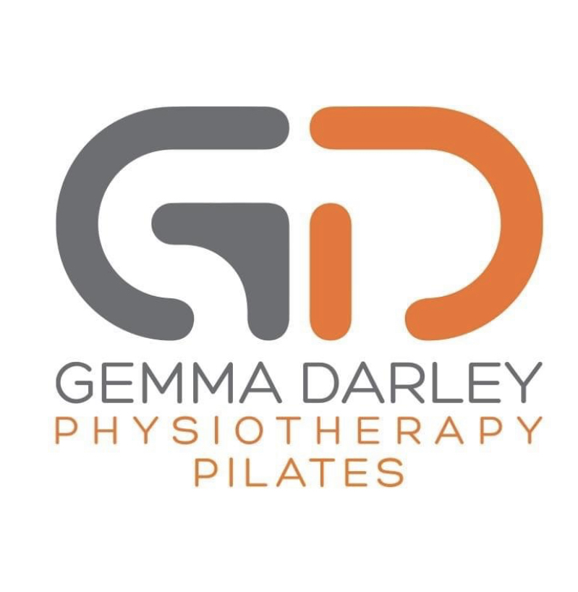

Personal Details

Name:

DOB:

Email Address:

May I keep you up to date via email on the latest GDPilates info: Yes No

Your Pilates Aims
What interested you in Pilates?

Have you done Pilates before? Yes No

Are there any specific areas of the body you would like to concentrate on?

Your Lifestyle

What is your occupation?

Does your occupation involve any repetitive of prolonged postures? If so, explain briefly:

What other Sports/hobbies are you involved in?

Your Health
Please give any information on any health conditions that you feel your Pilates instructor should be aware of prior to you completing a course of Pilates: (Eg. Low back pain, any previous fractures, heart problems, high or low BP, Epilepsy, Arthritis, Asthma, Pregnancy)

Your Riding
Below, please let me know any particular times when riding that you feel as a rider that you are perhaps letting horse down and not the other way round? (eg. All horses you ride lean on right rein, can’t maintain leg position in sitting trot, tension within shoulder not allowing relaxed position)

Consent
The Pilates program will begin at a low level and will be advanced in stages depending on your fitness level. It is important for you to realise that you may stop when you wish because of feelings of fatigue or any other discomfort.
There exists the possibility of certain dangers when exercising. They include abnormal blood pressure, fainting, irregular, fast or slow heart rhythm, and in rare instances, heart attack, stroke or death. Whilst every care will be taken, it is impossible to predict the body’s exact response to exercise. Every effort will be made to minimise these risks by evaluation of preliminary information relating to your health and fitness.
I understand that the Pilates programme will be specifically designed to the group’s ability and will take into account details given in my health questionnaire.

Sign………………………………………………………………………………….Date…………………………………

Please return the completed form to; gemma@gemmadarleyphysio.com
BACS Details:
Please note payment is to be received prior to attending course
Total Cost: £40.00
MISS GEMMA L DARLEY
11-05-12
11063165

